RESOLUTION NO.__________

RE: CERTIFICATE OF APPROPRIATENESS UNDER THE
PROVISIONS OF THE ACT OF THE PENNSYLVANIA
LEGISLATURE 1961, JUNE 13, P.L. 282 (53
SECTION 8004) AND BETHLEHEM ORDINANCE NO.
3952 AS AMENDED.

WHEREAS, it is proposed to install a fence on the property line at
115 E. Wall Street.

NOW, THEREFORE, BE IT RESOLVED by the Council of the City of Bethlehem that a Certificate of Appropriateness is hereby granted for the proposal.

Sponsored by:

ADOPTED BY COUNCIL THIS DAY OF , 2016

President of Council

ATTEST:

City Clerk

HISTORICAL & ARCHITECTURAL REVIEW BOARD

The applicant proposes to install a fence along the property line at 115 E. Wall St.
APPLICATION #1:

Matt & Dorothy Henderson
115 E. Wall St.
Bethlehem, PA 18018

OWNER:

__________________________________________________________________

The Board upon motion by Marsha Fritz and seconded by Gen Marcon adopted the proposal that City Council issue a Certificate of Appropriateness for the following:

- Fence to be black metal painted semi-gloss black.

2. To be installed along both street frontages and across rear property line.

3. The fence will be supplied by Rustic Gardens.

4. There will be two gates 1-4ft., pair totaling 12 ft. +/-.

5. The motion was unanimously approved.

__________________________________________________________________________

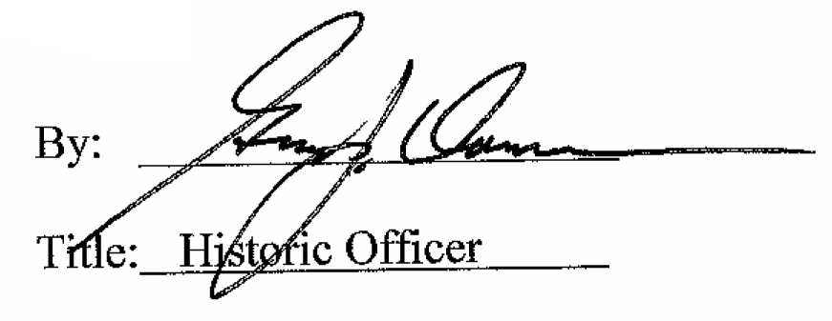

Date of Meeting: April 6, 2016

